Master Mind – Console app

Author: Tomasz Orpik

Index: 11757

Game Modes:

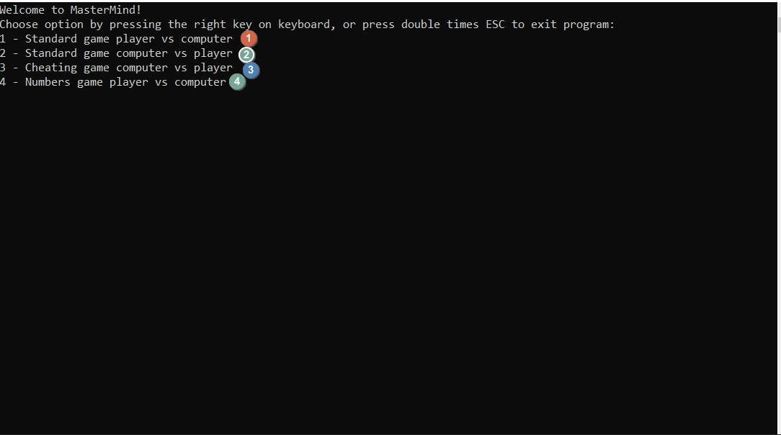

1. Play standard mode game, where players guess secred code created by computer
2. Play standard mode game, where computer guess secred code created by player
3. Play game, where computer guess secret code created by player, but player can cheat by inputing wrong anserws
4. Play game, where player guess secred code created by computer, with numbers in place of colors.
5. :
6. Start settings:

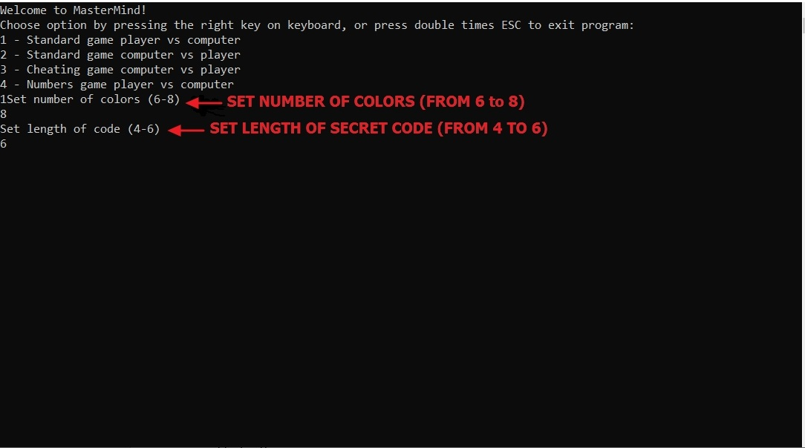

1. Code insert:

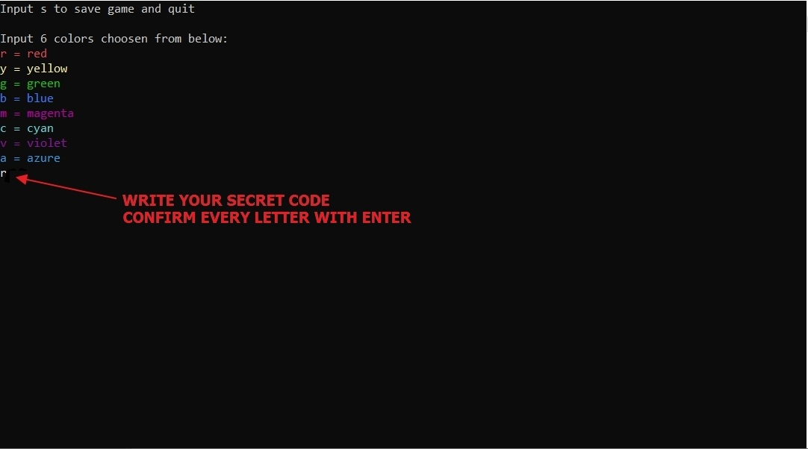

1. Counters:

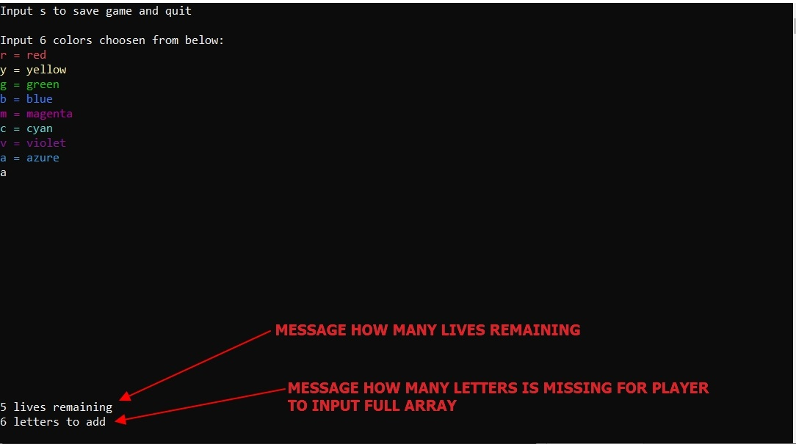

1. Results:

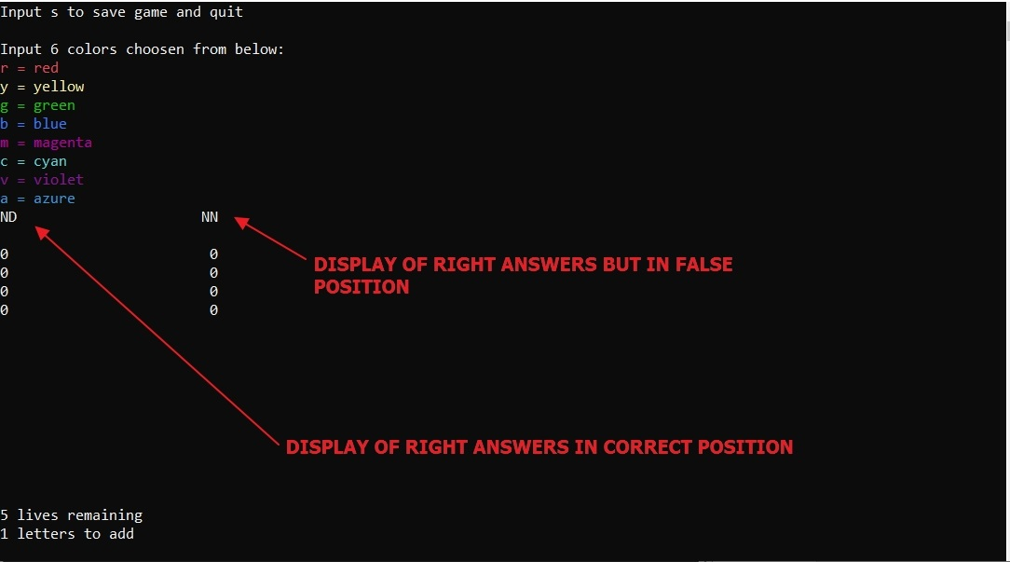

1. :
2. Start setting:

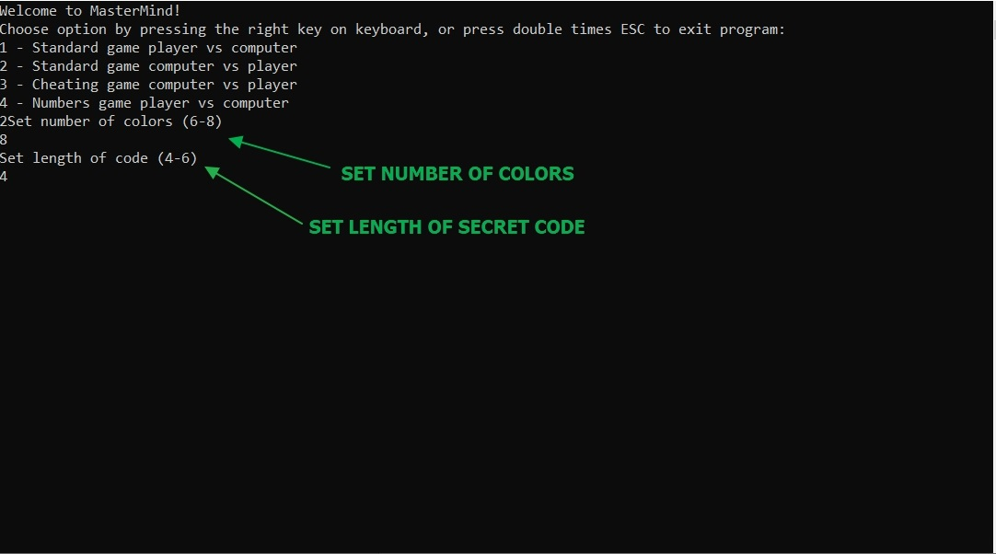

1. Code Insert:

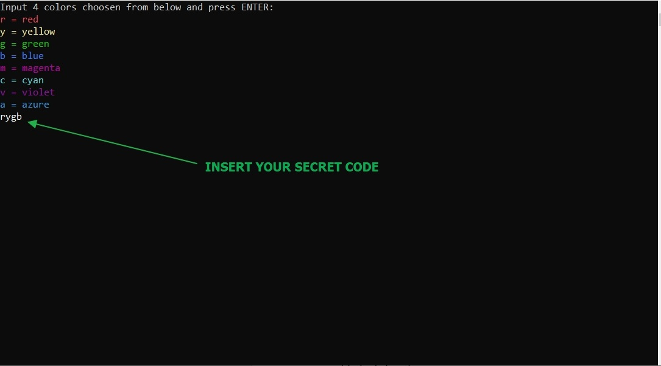

1. Counters:

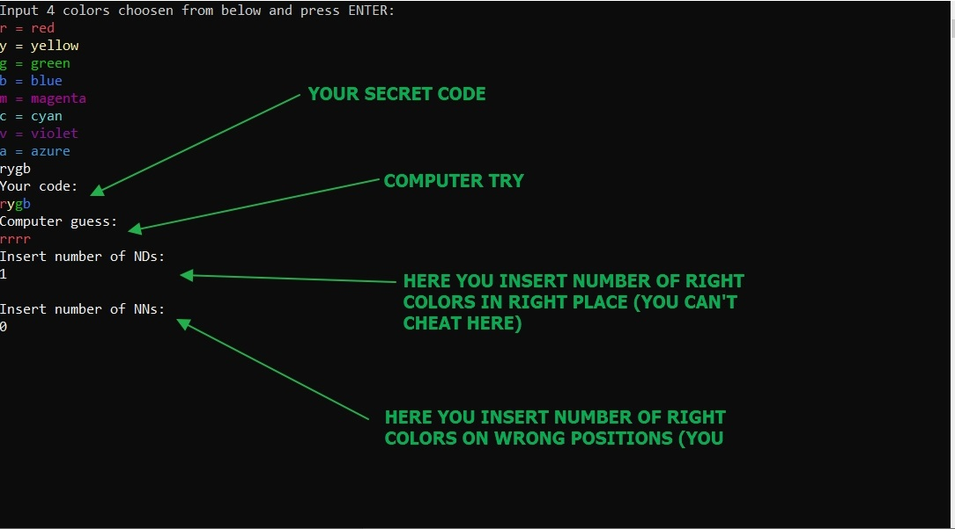

1. Result:

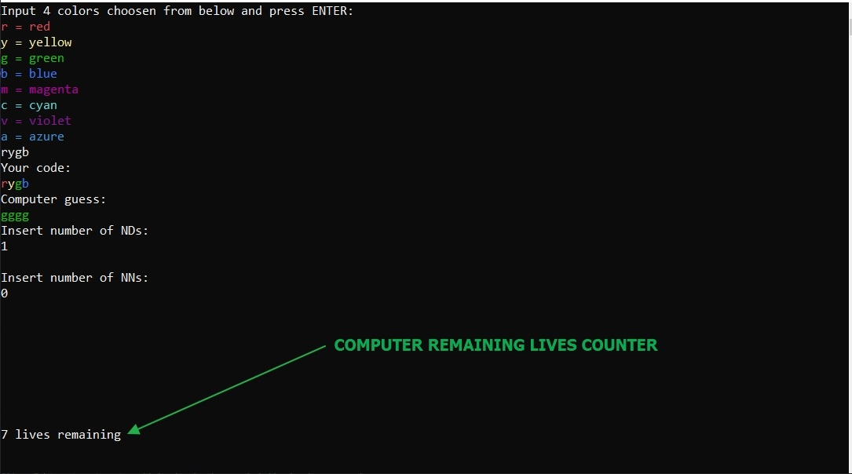

1. :
2. Start Setting:

1. Code Insert:

1. Counters:

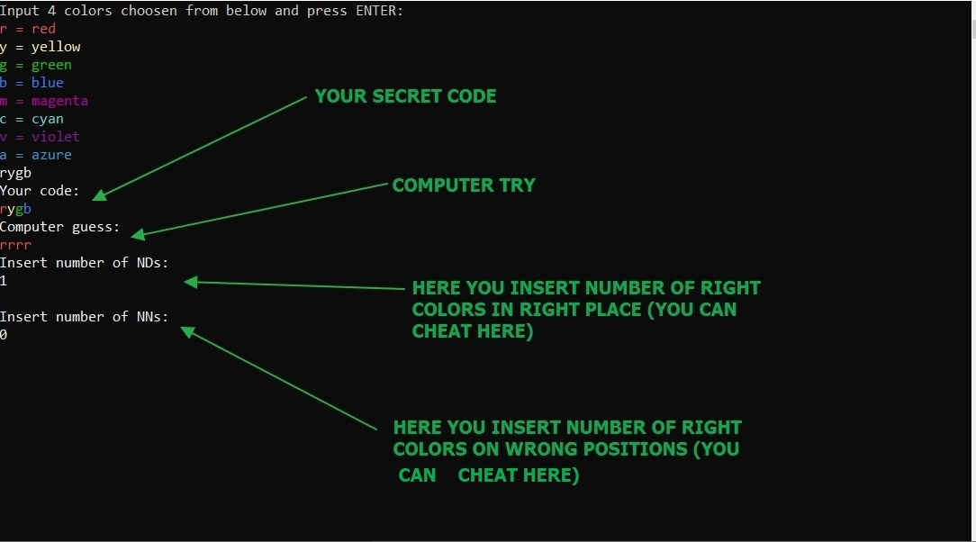

1. Result:



1. :
2. Code Insert:

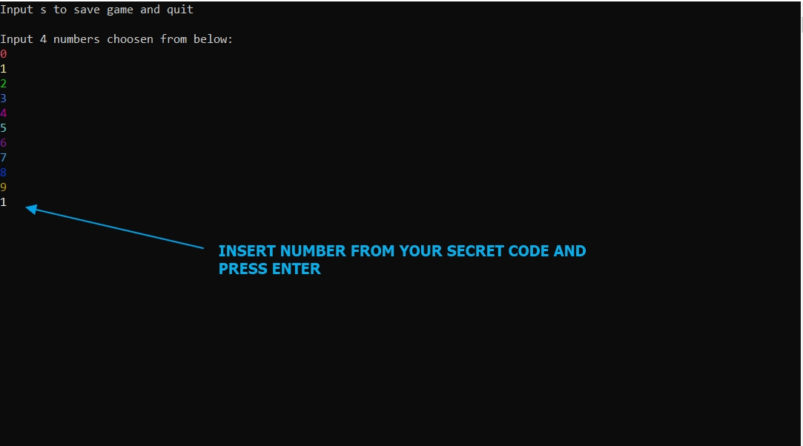

1. Counter:

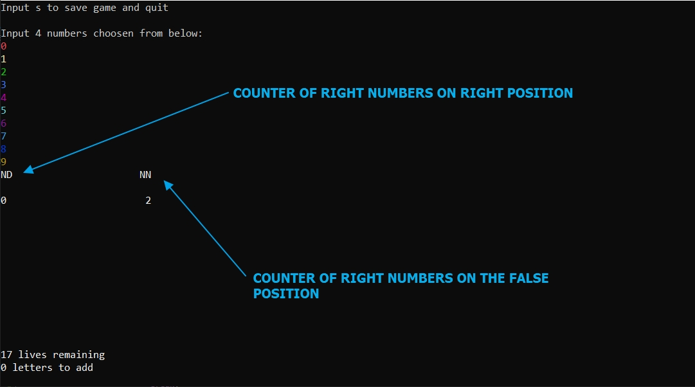

1. Result:

